ECC PT1(11)162_Annex23

 Electronic Communications Committee (ECC)
within the European Conference of Postal and Telecommunications Administrations (CEPT)
CEPT ECC PT1 INTERNAL REPORT ON MOBILE BROADBAND LANDSCAPE

September 2011

EXECUTIVE SUMMARY
This CEPT ECC PT1 internal Report presents the most recent information available (as of year 2011) on mobile broadband deployment statistics, trends and plans in different CEPT countries and also forecasts for future.

Mobile broadband traffic is increasing, driven by several factors like improved performance of mobile networks and the availability of new devices, like smartphones and tablets, and new mobile applications introducing new ways using mobile devices and services. There is clearly a demand for high data-rate services in the mobile environment.

This CEPT ECC PT1 internal Report indicates that the previous forecasts made prior to WRC-07 greatly underestimated the growth of mobile data traffic. There is a need to review the spectrum estimates due to the traffic predictions showing faster growth than estimated before.

Table of contents

0 EXECUTIVE SUMMARY 2
1 INTRODUCTION 6
2 mOBILE BROADBAND global trends 7
2.1 An enhanced network environment: more capable networks 7
2.1.1 Technologies enabling high data rate are deployed heavily in the coming years 7
2.1.2 Good coverage helps the mobile broadband penetration 7
2.1.3 Mobile internet substitution/fixed complementarities 7
2.2 Better device diversity and performance 8
2.2.1 Smartphone penetration in a global scale 9
2.2.2 The role of data cards (dongles) in the data traffic explosion 10
2.3 The mobile broadband service offerings and its implications to traffic 10
2.3.1 Voice traffic 10
2.3.2 Short Messaging is increasing 12
2.3.3 Multimedia Messaging has not been widely adopted 13
2.3.4 Social networking is booming 13
2.3.5 Machine-to-Machine (M2M) traffic is growing rapidly 14
2.3.6 Mobile Internet is the key mobile application 16
2.3.7 Peer-to-peer (P2P) traffic becomes more and more important 17
2.3.8 Growing Video traffic is the main contributor for mobile data traffic 18
2.3.9 Users age and its impact to mobile traffic growth 19
2.4 Mobile broadband in CEPT countries 21
2.4.1 Mobile broadband traffic within CEPT 22
2.4.2 Mobile broadband penetration rates within CEPT 23
3 MOBILE BROADBAND FORECASTS 25
3.1 Previous forecasts 25
3.1.1 Estimates for year 2020 daily traffic per subscription [4] 26
3.1.2 Estimates for year 2012 daily traffic per subscription [4] 26
3.2 Comparison of previous estimates to current mobile broadband traffic statistic 26
3.3 New forecasts from UMTS Forum for a “representative Western European Country”[6] 29
3.3.1 Total mobile traffic 30
3.3.2 Daily traffic 31
3.3.3 Daily traffic per subscription 31
3.3.4 Busy hour traffic 31
3.3.5 Conclusion on mobile traffic forecast [6] 32
3.3.6 Estimate beyond 2020: 2025 forecasts [6] 32
5 MOBILE BROADBAND PLANS IN CEPT COUNTRIES 33
5.1 Andorra 33
5.2 Austria 34
5.3 Cyprus 34
5.4 Czech Republic 34
5.5 Denmark 34
5.6 Estonia 34
5.7 Finland 34
5.8 France 35
5.9 Iceland 35
5.10 Ireland 35
5.11 Latvia 35
5.12 Malta 35
5.13 Poland 35
5.14 Russian Federation 36
5.15 Slovak Republic 36
5.16 Sweden 36
5.17 Switzerland 36
5.18 The Netherlands 36
5.19 United Kingdom 37
5.20 European Union 37
6 conclusion 37
LIST OF REFERENCE 39

List of abbreviations

Data cards (dongles) refer to the type of usage rather than the physical device: today, data cards (dongles) are external devices which add connectivity to portable computers. In the future, this functionality will be more frequently integrated within portable computers.

Digital dividend: is the additional spectrum that is becoming available for new wireless and TV services as a result of the switchover from analogue to digital TV

Abbreviation | Explanation
CAGR | Compound Annual Growth Rate
CATV | Cable Television
DSL | Digital Subscriber Lines
EDGE | Enhanced Data Rates for GSM Evolution
EU5 | France, Spain, UK, Germany, Italy
EU27 | European Union
GB | Giga Bytes
HD | High Definition
HSPA | High Speed Packet Access
LTE | Long Term Evolution
M2M | Machine to machine
MMS | Multimedia Messaging Service
PCs | Personal Computers
P2P | Peer-to-Peer
SIM | Subscriber Identity Module
SMS | Short Messaging Service
TB | Tera Bytes
UGC | User Generated Content
VoIP | Voice Over Internet Protocol

INTRODUCTION
Based on the need to review mobile broadband landscape in Europe, CEPT PT1 issued a questionnaire on mobile broadband during 2010. Based on the responses from CEPT Administrations and from the industry, this CEPT ECC PT1 internal Report summarises these responses and gives facts and figures on mobile broadband traffic and subscriptions and evolution of those for the last few years.

This CEPT ECC PT1 internal Report will be kept in CEPT PT1 web page (http://www.cept.org/ecc/groups/ecc/ecc-pt1) as long as the information in this Report is up to date.

mOBILE BROADBAND global trends
Mobile broadband services introduced through data-oriented networks are currently experiencing significant growth, driven by number of factors such as increased capacity in networks, a greater device performance and better service offering. This Report considers licenced mobile broadband systems and specifically Wi-Fi in public and private environment is not taken into account.

An enhanced network environment: more capable networks
The introduction of new, higher-bit rate mobile technologies (like High-Speed Packet Access, HSPA) from 2007 onwards has increased the service bit-rates and improved the reliability of mobile networks. This has led to better mobile broadband user experience facilitating e.g. the download of more internet pages in less time. The difference between user experience in mobile environment and fixed (cable) environment is becoming less significant as mobile networks can offer high user bit-dates.

Technologies enabling high data rate are deployed heavily in the coming years
The latest technology deployed by mobile operators is 3G+ or 3.5G (e.g. HSPA/HSPA+), which is gradually supplanting 3G (e.g. WCDMA). 3.5G encompasses technologies with theoretical (shared) connection speed ranging between 3.6 Mbps and 42 Mbps, which is close to DSL-type wired networks.

HSPA+ is the latest version of HSPA and some operators started deploying it in 2009. Although still considered as 3.5G, it offers considerably faster connection speeds which translate to a growth in data traffic.

According to Wireless Intelligence [7], by the end of 2010, there were 147 HSPA networks in Europe, including 40 HSPA+ networks. Based on latest set [7] of global LTE network forecasts and assumptions for years 2010-2015 (published in Dec 2010), there are already 15 live LTE networks with a further 170 planned by the end of 2015. LTE connections will surpass the 1 million mark in the first half of 2011 and will reach 300 million by 2015 (compared to the 350,000 in 2010). LTE network migration is being initially driven by operators in Western Europe and North America, which account for a combined 70% of global LTE connections in 2010.

Good coverage helps the mobile broadband penetration
3G and 3G+ coverage has increased over recent years but it varies between countries. Indeed, the first areas with mobile broadband coverage (3G and 3G+) were cities where the density of population is highest. Other areas are now being covered and refarming enables operators to deploy 3G in the 900 MHz band, which offers larger cell radius and better coverage than the 2.1 GHz band. Licensing of 800 MHz spectrum with good coverage characteristics, and 2.6 GHz spectrum will bring additional resources for mobile broadband roll-out. (see also ECO Report 03 “THE LICENSING OF MOBILE BANDS IN CEPT”).

Mobile internet substitution/fixed complementarities
Basically mobile broadband users seek the similar quality of service to what they have experienced using the fixed networks.

Today, there are more complementarities between fixed and mobile than fixed-mobile substitution. 3G dongles which provide connectivity enhance the attractiveness and the usefulness of personal computer for people on the move. This type of usage is more a complement than a substitute to the fixed line. However, fixed-mobile substitution is significant in a limited number of markets such as Austria or Sweden. This can be explained by the attractiveness of dongles, competitive prices for “unlimited” data packages and speeds offered by 3G+ networks.

Figure 1: Broadband growth in Austria and Sweden

At global level, the mobile coverage is more than 90% of population while global internet penetration is only 28.7%. So there is really a huge potential for mobile broadband to become a major access enabler for Internet.At European level, internet penetration is close to 60%.

Better device diversity and performance
The introduction of different kind of end-user terminals (tablets, M2M, notebooks, laptops and smartphones) with better performance is a major generator of traffic.

Global combined sales of laptops and smartphones overtook desktop personal computers (PCs) already in 2006, and number of current forecasts estimate that global sales of smartphones alone will overtake combined desktop PC and laptop sales by 2012.

The load of the mobile networks is impacted by those different end-user terminals. In some European countries, mobile broadband subscribers consume 1.8 GB (Gigabytes) per month which is around 72 times the amount of data used by a regular mobile phone. PC modem card users consume 1.4 GB per month (56 times the amount of data used by a regular mobile phone).

Smartphone penetration in a global scale
Currently, more than 30% of all mobile phones in the world are 3G-ready. According to [6], sales should reach 623 million units in 2012 thanks to continued 3G deployments in countries such as China and India. By 2012, 48% of handsets will be 3G-ready.

Figure 2: Nationwide distribution of 3G subscribers

Device evolution is one of the key enablers of the data traffic explosion on mobile networks. A significant step forward in technology was evidenced by the explosive growth of the smartphone segment. Dongle take-up is boosted by low prices. Tablets as a connected devices should also heavily impact mobile data traffic. In October 2010, Gartner forecast tablets at 19.5 million units in 2010 and 54.8 million units in 2011. Other new devices include portable game players, portable media players, digital cameras, digital photo frames, HDTVs, GPS devices.

The amount of smartphones in the market will significantly impact the development of the mobile broadband. Whilst smartphones are not must-haves for the mobile Internet, they are certainly the most suitable devices to satisfy high-quality user-experience expectations which users are used to in fixed/cable environment.

Figure 3: Share of smartphones in mobile shipments, 2007–2009

For every country and region, the share of smartphones in mobile shipments has been steadily increasing since 2007. In Japan and South Korea, purchase of smartphones remains low. The mobile market is already very advanced in these two countries, where "traditional" mobile phones already have good application offererings with well-established ecosystems. On the other hand, USA and EU27 leads shipments for smartphones. USA made a big leap in smartphone penetration in 2008, followed by EU27 in 2009. There are no big discrepancies between the countries of the EU5, and smartphone penetration remains similar between the USA and Japan/South Korea.

E.g in Europe, KPN Belgium says that 60% of its new customers now buy smartphones. Deutsche Telekom stated that smartphones accounted for 53 % of all handsets sold. Vodafone (Vittorio Colao) expects “smartphone sales in Europe to grow from 32% today to more than 70%” by 2013. TeliaSonera (CEO Lars Nyberg) stated “Today, 70% customers in Sweden are buying a smartphone with higher usage and average revenue per user as a result”.

The role of data cards (dongles) in the data traffic explosion
Data cards (dongles) refer to the type of usage rather than the physical device: today, datacards (dongles) are external devices which add 3G connectivity to portable computers. In the future, this functionality will be more frequently integrated within portable computers.

In addition to the popularity of smartphones, the take-up of the 3G data cards with affordable flat rate data subscriptions is another explanation for the fast take off in mobile data traffic. Indeed, laptops with dongles generate 450 times more traffic than handsets [6].

With the first offers introduced in 2008, Finland is the leader among advanced countries in terms of laptops with embedded 3G/HSPA modules. Today (first half 2010) almost 90% of Finnish mobile data traffic comes from dongles connected to laptops [6].

Another piece of equipment that should contribute to the growth in traffic is the tablet PC, assuming that shipments will increase significantly in the future when embedded 3G connection technology will become more commonplace. According to PC manufacturers, tablet PC will be a new way of computing. The tablet PC has high growth potential within the PC industry; some estimates [6] predict a six fold increase by 2014.

The mobile broadband service offerings and its implications to traffic
Mobile broadband services are currently experiencing significant growth, driven by consumer demand for mobile data. More and more consumers use different kind data applications with their mobile device: surf the web, check emails, log in and participate in community networks, watch videos - just to name few. Basically they like to use their mobile applications in a same manner as with any application they use in fixed connection in Internet.

E.g., from the France Telecom results as of October 2010, revenue from mobile services in France rose by 2.1% to EUR2.74 billion [7]. This growth was attributed to the success of new services and the continued development of smartphones. Data services represented 31.7% of network revenues in the third quarter of 2010, an increase of 5% compared with the third quarter of 2009.

This section gives an overview of the traffic generated by each mobile broadband service and applications..

Voice traffic
Mobile voice traffic will have a limited growth compared to mobile data traffic. Voice traffic was overtaken by data traffic in the mobile networks at the end of 2009 when the global amount of traffic was around 280 TB/month according to telecom industry players, [6]. Mobile voice traffic continued to grow in 2009 (see figures below) but at a lower pace with an annual increase of around 5% when compared to global traffic (growth rate between 100 and 150%), [6].

Figure 4. Mobile call per subscription per year

Figure 5. Voice and data mobile traffic growth rates in Netherlands and Sweden, 2008-2009

The mobile voice over IP (VoIP) may be adopted on mass scale in the next ten years and could trigger increases in the mobile voice traffic. This is mainly due to attractive pricing of international calls. However, mobile VoIP take-off depends on each country’s characteristics such as competitiveness of the mobile market, roaming pricing, trend for unlimited data plans and mobile operators' acceptance of mobile VoIP applications.

The two figures below illustrated the different trends between three European countries compared to USA in terms of mobile VoIP adoption, showing that between 8.4% and 17.5% mobile subscribers could use VoIP.

When considering the low capacity consumption of a mobile VoIP call – a well-known software application allows users to make voice calls where a minute consumes about 0.5 MB - the traffic from VoIP communication will then have little impact on the amount of capacity consumed in the mobile networks.

Mobile voice traffic growth will remain flat until 2020 and its contribution to global traffic is expected to be marginal.

Figure 6: Percentage of mobile VoIP users over total mobile subscribers, 2009-2014

Figure 7 : Mobile VoIP users, million, 2009-2014

Recent improvements in circuit-switched voice means high-quality voice services are now being offered by mobile operators through the use of high definition codecs (Wideband Adaptive Multi- Rate) for "crystal clear" mobile calls, thus reducing background noise. Given the quality offered with HD by Voice, some specific categories of users are targeted like business people and travellers for clear calls in public transport situations (buses, trains …).

Handsets manufacturers are committed to Mobile Voice HD. From the operators' side, "HD voice" service was first time introduced in UK across a 3G network in 2010. It is anticipated that other operators will follow suit mainly in advanced markets in coming years. According to the industry [6], more than 400 million mobile users will use mobile HD Voice by 2015.

Thus, it is expected that when HD Voice is adopted, mobile calls would last longer which then should offset the current trend of limited growth.

Short Messaging is increasing
Mobile messaging traffic volume continued to show strong growth on a global basis in 2009 and will continue to increase in the coming years driven by strong SMS adoption despite the increasing use of social networking sites and Internet Messaging (IM) applications accessible from user terminals. For instance, in France text messaging volume doubled in 2009 and in the United Kingdom with a 25% volume growth for the same period.

Within the global mobile traffic, the weight of mobile messaging is irrelevant. According to Cisco, mobile messaging represented less than 0.1% in 2009 mobile traffic.

.
Figure 8: SMS volume in France (from the ARCEP)

Figure 9: Annual average of SMS sent per subscription in Nordic countries

Multimedia Messaging has not been widely adopted
Multimedia messaging (MMS) offers text with pictures, video and/or audio files. Unlike for successful SMS take-up, MMS has not been widely adopted. It is estimated by industry players and regulators that MMS accounted for 2% to 3% of mobile messaging in 2009, [6].

MMS has not yet taken off, because of disincentive factors concerning interoperability (issues on mobile networks or handsets not supporting MMS) and pricing. Moreover, it is now more common to send a picture/video/audio as an email attachment or to share it through any social website rather than sending a MMS.

The best scenario for MMS adoption is in countries with high mobile penetration (like in some Asian countries) where MMS can be the support for any entertainment updates, movie trailers, etc.

Social networking is booming
Since 2006, social networks have seen an usage explosion: a growth of the traffic and a greater portion of online time devoted to these sites. Social networking has made it to the masses particularly on the fixed networks. Almost 70% of Internet users worldwide visited at least one social network in July 2009.

On the mobile networks, social networking is experiencing a surging popularity akin to that seen on the fixed networks and is the fastest growing mobile applications for the time being among. According to Allot, a social network service increased its traffic consumption by 200% during the first half of 2010 while a social networking and microblogging service grew by 310% in the meantime
.
Figure 10: Social networking growth applications, 1H2010

This growth can be explained by easy access to such services through smartphones but also the ability to access the services at any time: users with a well-known social networking mobile applications installed on their smartphones are twice as active as the average user of this application. In April 2010, it is estimated that more than 75% of smartphone users accessed social network sites. When considering the whole mobile terminal market, this number is much lower with an estimation of 20% of all mobile users accessing social networking sites.

Also, the impact of social network applications on mobile network traffic is increasing. For example in UK, half of mobile web traffic is from social networking application use. On another hand, the integration of location-based functions with social networks can lead to a more traffic consuming application on mobile networks.

In the future social networking applications are expected to continue to drive mobile data consumption.

Machine-to-Machine (M2M) traffic is growing rapidly
By end 2010, the M2M market represents 53 million modules worldwide. This market is growing very quickly within the wireless field. An overall growth for the next four years should top 33% per year for cellular modules, reaching 165 million in 2014. In 2014, M2M SIM cards will probably represent 2.5% of total SIM cards (human and machine) and over 8.1% of total SIM cards in Europe [6].

Figure 11: Cellular M2M Modules/SIMs (million units)

Figure 12: World M2M market, 2009-2013 (million EUR)

The growth of the wireless M2M market has been mainly sustained by a few major vertical markets such as fleet management, industrial asset management, point of sales, and security. Healthcare is the next and most promising market, but there is no discernible rush to enter it.

According to specialists, M2M for security is already a mature market. Fleet management is also an advanced market in terms of M2M usage used by logistics companies and the retail industry to monitor their trucks and shipping. M2M has also a great potential in the energy domain thanks to the commitment of national governments and industries to deploy smart metering solutions: 40 million smart meters are planned to be deployed in USA by 2015, 33 million in France by 2017, 170 million in China by 2015.

Moreover, consumer electronics is gaining traction in the M2M space driven by the success of connected e-readers, connected Portable Navigation Devices, photo frames and speed camera prevention systems. The arrival of new consumer electronics has had a great impact on M2M growth in general and in module sales growth particularly. As they address the mass market, consumer electronics will dominate in volume terms in the near future. Automotive applications, especially with expected e-call service, should be a key driver in the M2M market where we can imagine SIM cards embedded within vehicles. Driven by consumer electronics, it is expected that the market grows at a very rapid pace as indicated in ref [6].

In terms of traffic, the M2M share will depend on related applications. For instance, in the future, smart utility meters dedicated to equip homes consume some hundreds of kB while surveillance video monitoring should use tens of MB.

Mobile Internet is the key mobile application
The range of applications used by mobile Internet users is widening and differs from one country to the next. According to Nielsen [6], email became the number One application in 2010 followed by social networking.

There are now 95 million mobile Internet users in Europe and 55 million mobile Internet users in USA in 2009. The higher take-up of smartphones, which are tailor-made for mobile Internet experience, is a key driving force in the significant growth of the mobile Internet market. Most mobile Internet services are extensions of the PC-based Web and focused on entertainment.

At this stage, compared to the most developed countries, Europe has a large potential of growth in mobile Internet users in the next few years in terms mobile Internet users (see figure hereafter), .

Figure 13: Mobile Internet users, million, 2007-2014

Figure 14: Mobile Internet penetration rate 2007-2014

Peer-to-peer (P2P) traffic becomes more and more important
Like in fixed broadband networks, P2P applications generate a significant share of traffic in mobile networks with the large-scale use of file sharing applications. This is mainly due to the democratization of media files transferring. According to Cisco, P2P represents 17.1% of global traffic, the second largest mobile traffic consuming application.
Regarding geographical distribution, the average share of P2P file sharing accounts for 18.4% of mobile broadband traffic in Western Europe in 2009. This figure is in line with Allot distribution (figure 16) assuming that 17% is the weight in Europe; 18% in Americas and 23% in APAC region.

Figure 15: P2P contribution in mobile broadband traffic in global scale

Figure 16: P2P weight in the mobile broadband traffic in Americas, EMEA and APAC

However, on a global basis, P2P application is still growing but according to Cisco, P2P share of overall mobile traffic is forecasted to decline in the years to come and will only represent 7.8% of the traffic by 2014.

Growing Video traffic is the main contributor for mobile data traffic
Analysts predict that demand for data-heavy mobile video content (such as streaming video, flash and Internet TV for series, news, sports, etc.) will grow significantly over the coming years, such that it will account for 66% of mobile data traffic by 2015.

Various forms of video
Mobile video generally refers to real time entertainment consumption of video streaming, generic Flash video and other various webcasts. However video sharing has also emerged as a new way to consume audiovisual content, and has particularly been adopted by fixed Internet users. For many viewers, consuming a video means no longer just watching it, but also sharing it with their community, commenting it, blogging about it, tagging it, etc. This is why the online video market is largely dominated by community-based sites and social networking. The video sharing platforms based on user generated content (UGC) (such as YouTube, Dailymotion, Myspace) are becoming mainstream for mobile users according to Sandvine [6]. Moreover, uploading videos on one’s social networking profile is becoming also a way to share video. Hence, community networks are now video viewing sites in their own right. Catch-up TV (professional content made available for a limited period just after the broadcast diffusion) is also a way to watch video. The content is generally focused on TV series and TV specific programs. However, few services are for the time being available on mobile devices.

Mobile TV
Generally, TV refers to video applications proposing TV content mostly accessible through downloading or streaming. If we consider TV on mobile as strictly speaking a live TV service offered by mobile network operators, this usage would appear to be rather insignificant despite the many offerings. However, for specific events like the World Cup audiences can be exceptionally high compared to the everyday usage.

Video traffic growth
When talking about video content, it covers all kind of TV content, however, it is distinguished in short form videos (professional and UGC) and medium/long-form videos. On mobile devices, for the time being, a short clip is the adequate form of viewing videos. These clips, generally found on web portals or on specialized video portals, are often related to sports highlights, music (TV clips), movie trailers, humor, news, video game trailers…

Video content is mainly watched using PC via dongles. Today, the relative decline of P2P traffic (see the previous section of P2P traffic information) in the overall Internet traffic is mainly due to the shift from P2P file sharing to video streaming websites. Indeed, the sharp increase in real-time streaming video consumption is heavily impacting mobile traffic volumes.

Both streaming and file sharing are the heaviest traffic sources and represent more than 50% of all traffic in 2009 in Western Europe and generating the highest growth rates (close to 100% growth for HTTP streaming). According to YouTube, mobile viewing content grew by 160 percent in 2009 and a strong growth was also experienced in 2010.

For the coming years, video will be responsible for most mobile data traffic growth through streaming or downloading with a compound annual growth rate (CAGR) exceeding 100% between 2009 and 2014.

Figure 17: Data traffic distribution in WCDMA networks in Western Europe

Users age and its impact to mobile traffic growth
The age of the users and consequently the way of using Internet has changed over the last years, resulting in an increasing demand. There are two main streams which can be manifested:
- The age of the users is extending at both ends of the human live-cycle: more and more elderly people start using the Internet and the younger generation is getting educated to the Internet through school and kindergarten at a very young age.
- In particular the new, younger generation is using the Internet for social networking, games, online education, net-homeworking for learning and studying.

In one Report addressing this fact, over 95% of the age group 15-49 had an Internet subscription and slightly over 80% of those in the age group 50-64 and 50% of older age groups had an Internet subscription. The figure below (Figure 18) depicts the Internet subscription penetration by age group in 2010 based on Finnish market noting that “n” represents the number of observations in the market survey – in this case people in particular age group who have been asked the question in telephone interview.

It is seen that it does not show the people below the age of 15, though the importance of this group is increasing dramatically.

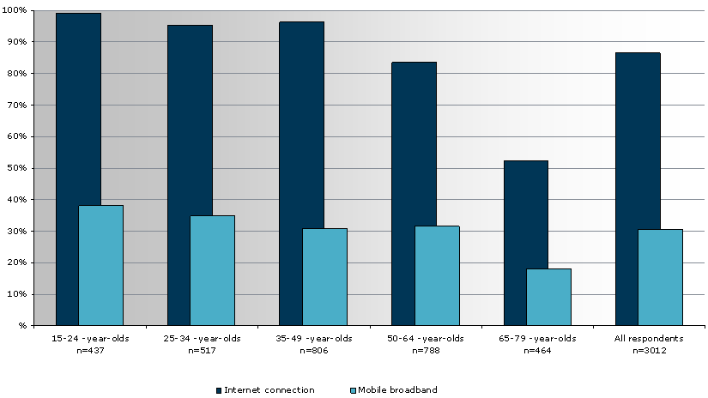
Figure 18: Internet subscription penetration by age groups in 2010 for Finland
Furthermore, the Figure 19 shows mobile broadband use by age group in 2010 based on the consumer survey in Finland. When viewed by age group, it is noticed that people aged 25-34 are the most active and diverse mobile broadband users, followed by those aged 35-49. The age group 15-24 was the most active user of mobile Internet communication services.
.
Figure 19: Mobile broadband use by age group in 2010 for Finland

It is worthwhile to note that although the figures do not show the people below the age of 15, the importance of this group is increasing dramatically.

Mobile broadband in CEPT countries
This section gives an overview of the mobile broadband in Europe. Information has been collected through various sources like:
- CEPT Administrations: in 2010, ECC PT1 gathered the information of traffic statistics and mobile broadband penetration rates after sending a questionnaire to CEPT administrations;
- UMTS Forum contribution [6];
- GSMA contribution [7].
- Other contributions received

Due to some difference in terms of mobile broadband definition and indicators through CEPT countries (for example, instead of per subscriptions, responses indicated traffic (and penetration) per subscriber, per customer or per connection), the indicated figures have to be read carefully. They still give a good overview of the current mobile broadband situation.

Note1: 1TB (TeraByte) =1000GB (GigaByte) =8000Gbits.
Note2: Traffic is rounded to the nearest integer.
Note3: ‘.’ denotes the integer/decimals separator, i.e. 1.5TB=1500GB.

Mobile broadband traffic within CEPT

Table 1: Mobile broadband total traffic statistics per country (per month)
Country | Total Traffic (TB/month) | Notes (Response from questionnaire)
Germany | 2792 | 33.5 million GB in 2009
Sweden | 2787 | (893000x2622+418000x1065) MB/month
Netherlands | 2339 | 2339794000 MB in Dec. 09
Austria | 1667 | 5000000 GB in Q4/2009
Finland | 1667 | 10000 TB in H2 2009
Denmark | 771 | 4626 million MB in H2 2009
Ireland | 660 | 602379+57626 GB/month in Sept. 09
Portugal | 199
Slovak Rep. | 121 | 5% penetration, 15MB per subscriber per day
Switzerland | 58 | 701715000000 Kilobytes in 2008
Estonia | 41 | 123 million MB in Q1 2010
Croatia | 31
Russia | 27 | October 2010; the data is only relevant to UMTS in 2.1 GHz band
Iceland | 19 | 224017299 MB in 2009
Malta | 7 | 83924 GB in 2009
Andorra | 0 | 42218360000 Bytes/Month

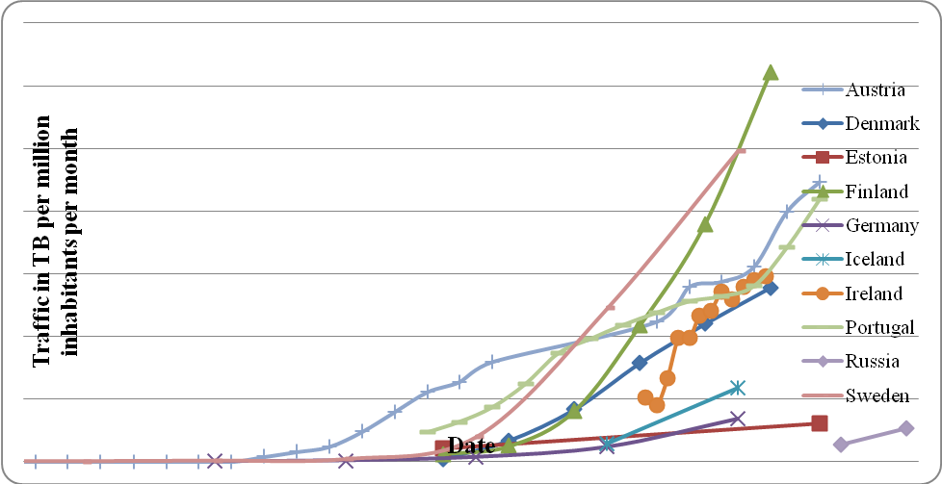
Figure 20: Evolution of mobile broadband traffic

In order to get the daily traffic per subscription, the overall country traffic has to be calculated per day. Then that has to be divided by the amount of mobile broadband subscriptions. The below table indicates daily traffic statistics per county:

Table 2: Mobile broadband daily traffic statistics
(from 2009-2010)
Country | Mobile broadband traffic per day
Sweden | 61 MB
Finland | 61 MB
Hungary | 45 MB
Denmark | 43 MB
Austria | 42 MB
Ireland | 42 MB
Iceland | 31 MB
Estonia | 18 MB
Croatia | 16 MB
Slovak | 15 MB
Germany | 4.8 MB
Netherlands | 2.3 MB
Malta | 0.5 MB

There is a lot of variation between CEPT countries, depending on several issues e.g. pricing (flat rate) offers from operators. As stated before, this variation is also due to some variations of definition of Mobile Broadband and variations related to the unit used with received information.

TeliaSonera released figures on data use on their networks in November 2010 which benchmark closely to other user figures from around the world showing that an average smartphone user consumes upward of 12.5MB/day, 3G modem use an average of 167MB/day and that LTE user is consuming 500MB/day.

Mobile broadband penetration rates within CEPT
The following summary of user penetration of mobile broadband (penetration % of the total population) can be drawn:

Table 3: Mobile broadband user penetration
Country | Penetration rates (%) | Notes (from the questionnaire responses)
Sweden | 63 | From http://www,statistik,pts,se/pts2009/index,html
France | 39 | 24.4 million of active multimedia customers on 30/06/2010
Netherlands | 30.8 | 4594000+533000 in Dec 2009
Denmark | 29.6 | 1636000 subscriptions end 2009
Germany | 23.2 | 19 millions in 2009
Switzerland | 23 | 1813700 users on 31/12/2008
Portugal | 19.5 | By 15/02/2010
Estonia | 19 | active MB users = 18%-19% Q1 2010
Latvia | 17.6 | 391000 in January 2010
Finland | 17 | 908000 users on 31/12/2009
Austria | 15.4 | 1291000 mobile broadband users in Q4/2009
Malta | 15.1 | 62345 on 01/2010
Ireland | 12 | 540,546 in Q3 2010
Croatia | 6.4 | 289000 mobile broadband users by mid 2010
Poland | 6.4 | 2460105 mobile broadband subscribers by 30/06/2010
Iceland | 6.2 | 19755 out of 317630 end of year 2009
Russia | 6 | By 15/10/2010
Andorra | 5.4 | 4500 users
Slovak Rep, | 5 | Approx 5%
Czech Republic | 3.5 | 3.53% in Dec 2009
Cyprus | 1.1 | 1.1% in January 1st 2010

The evolution of the mobile broadband user penetration is indicated in the figure below in percentage of the total population.

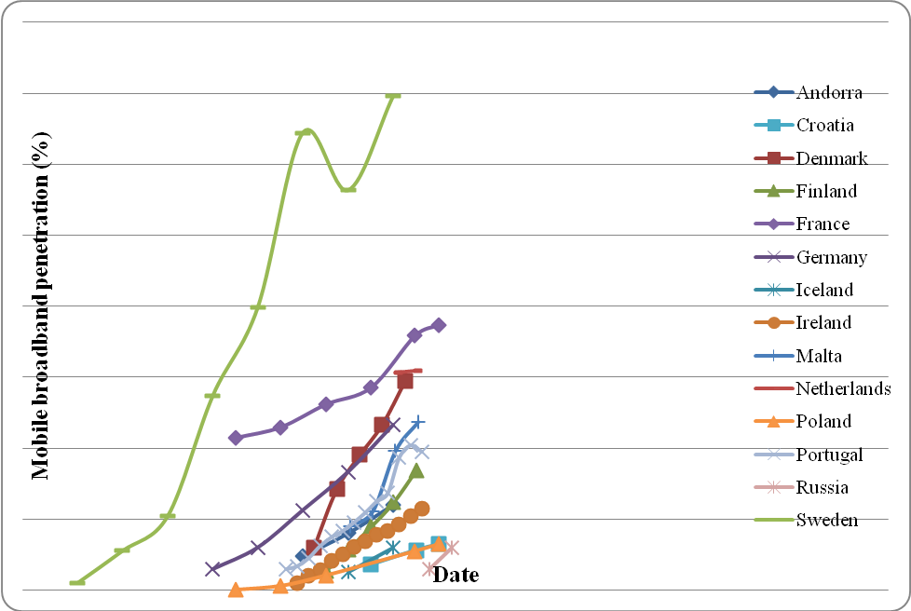
Figure 21: Evolution of mobile broadband user penetration

Note 1: The definition of mobile broadband changed in Sweden and therefore the temporary decline in Swedish penetration curve.
Note 2: Some differences between countries are caused as stated before by the fact that the definition of mobile broadband differs country by country.
- MOBILE BROADBAND FORECASTS
This section recalls the previous forecast done prior WRC 07 (see e.g. [4]) and provides revised forecasts up to 2025 [6].

Previous forecasts
One of the estimates done prior WRC-07 was UMTS Forum Report 37 [4] and this estimate is also included in ITU-R M.2072 “World mobile telecommunication market forecast”, section 6.2.6. Report 37 estimated that from 2012 to 2020, total daily traffic in the Representative Western European country will grow from 250TB to approximately 5 750TB.

In below Figure 22, this estimate together with another one, which estimated the global mobile traffic (WLAN offloading traffic excluded) up to year 2020, are presented. Both are taken from Report ITU-R M.2072 (done at the year 2005).
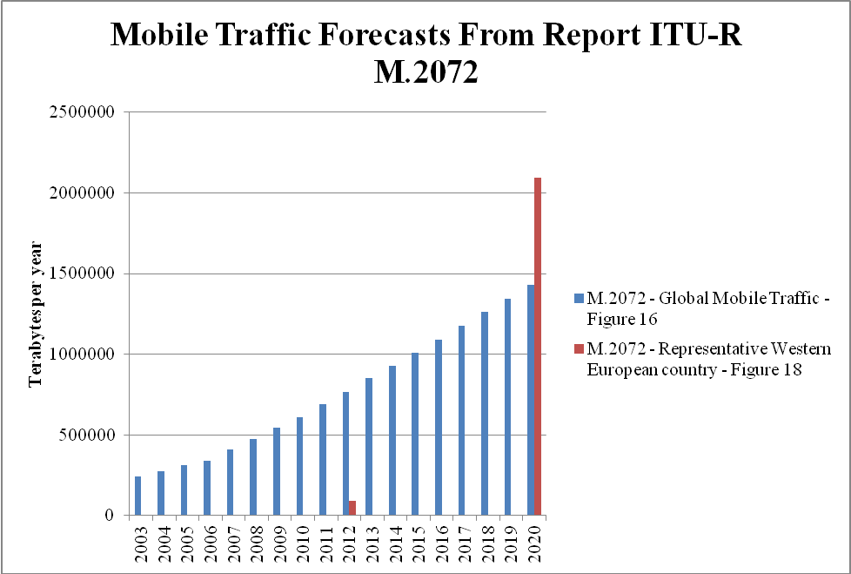

Figure 22: ITU traffic estimates done at year 2005 (Report ITU-R M.2072)

Estimates for year 2020 daily traffic per subscription [4]
The estimated total daily traffic per subscription was 495MB. This then corresponds that a representative European country would have 11.6 million subscriptions.

Estimates for year 2012 daily traffic per subscription [4]
At the year 2012, all subscriptions (all serviced considered) were estimated to be 128.1 million, which is 76% of year 2020 estimate (168.5 million). Therefore, 76% of year 2020 figure of 11.6 million could be used to calculate a representative European country subscriptions at year 2012, yielding at 8.8 million.

Then the daily traffic per subscription at can be estimated 250TB / 8.8 million = 28 MB/day/subscription in 2012.

Comparison of previous estimates to current mobile broadband traffic statistic
The global estimate from Report ITU-R M.2072 (2005) were quite conservative compared to the actual mobile traffic (Wi-Fi offloading traffic not included) rise from 2007 to 2010, as shown in the Figure 23.

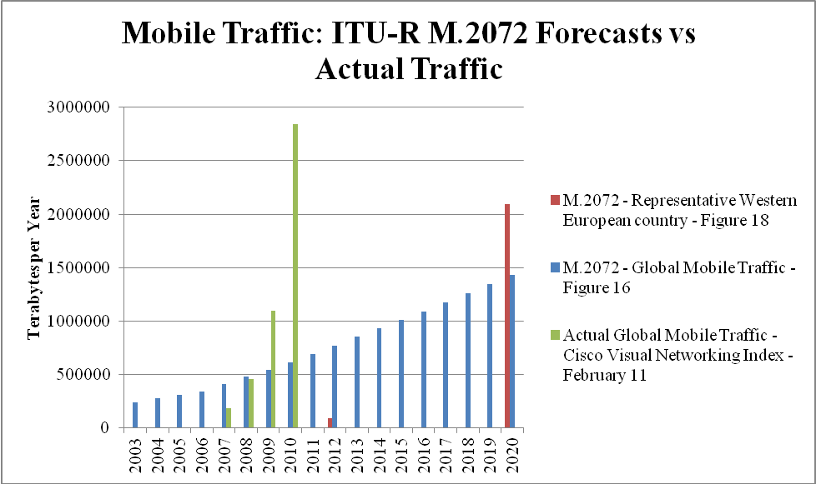

Figure 23: Comparision between traffic forecasts from report itu-r m.2072 and actual global mobile traffic (2007-2010

Though the global mobile traffic forecasts from Report ITU-R M.2072 were quite conservative, it should be highlighted that traffic forecasts from the European Commission Joint Research Centre, (referred to below as the FMS Report), published in 2005 were already predicting significantly bigger traffic growth. The comparison of the traffic growth forecasts from both 2005 reports are detailed in Figure 24.

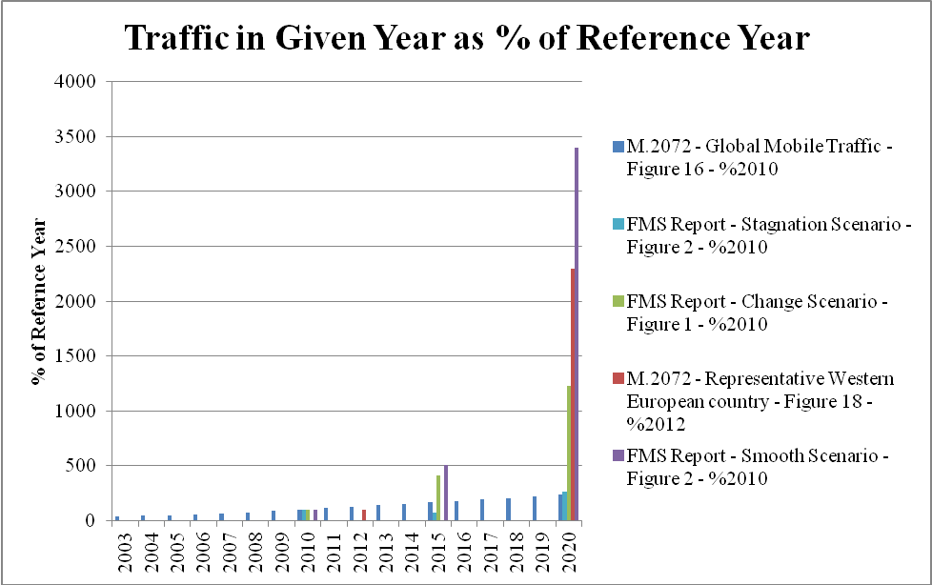

Figure 24 : Comparision of 2005 forecasts of traffic growth

Related to observed mobile broadband traffic in European countries, Table 2 is reprinted here so that comparison can be done. Note that previous forecast was for a representative European country of 8.8 million mobile broadband subscriptions. Also information added from GSMA from section 5.2.

Table 4: Daily mobile broadband data statistics and an estimate from ITU-R M.2072
Country | Date | Mobile broadband traffic per day
Sweden | 2009 | 61 MB
Finland | 2H 2009 | 61 MB
Hungary | June 2010 | 45 MB
Denmark | 2H 2009 | 43 MB
Austria | Q4 2009 | 42 MB
Ireland | Q1 2010 | 42 MB
Iceland | 2H 2009 | 31 MB
Estonia | Q1 2010 | 18 MB
Croatia | 22 2010 | 16 MB
Slovak | n/a | 15 MB
Germany | 2009 | 4.8 MB
Netherlands | 2H 2009 | 2.3 MB
Malta | Q1 2010 | 0.5 MB
GSMA/Telia Sonera | November 2010 | 12 MB  (average smartphones)
GSMA/Telia Sonera | November 2010 | 167 MB  (3G modem)
GSMA/Telia Sonera | November 2010 | 500 MB  (LTE user)
ITU-R M.2072  (UMTS Forum)  Estimates from 2005 | 2012 | 28 MB
ITU-R M.2072  (UMTS Forum)  Estimates from 2005 | 2020 | 495 MB

The above figure reveals that the previous forecasts made prior 2007 greatly underestimated the mobile data traffic. This is one reason, why the forecasts should be reviewed with due consideration of current facts and trends.

New forecasts from UMTS Forum for a “representative Western European Country”[6]
In this new UMTS Forum forecast [6], a representative Western European country will have 85 million subscriptions in 2020.

Table 5: Population and subscriptions- Representative Western European Country

In the representative European country, in year 2020, having a population of 50 million and subscriptions of more than 85 million, the total amount of traffic generated by smartphones reaching 6.9 GB in average, is more significant than the 15 GB generated by the dongles, for the reason that the dongles are fewer in numbers.

Figure 25: Monthly traffic per device (representative Western European country)

In our hypothesis, the traffic generated by dongles in 2020 is similar to the traffic generated today by a fixed connection on Digital Subscriber Lines or CATV/Cable TV networks.

Table 6: Monthly traffic per device (MB – representative Western European Country)

Total mobile traffic
The total mobile traffic in a representative Western European country will rise from 1,860 PB in 2015 to 4,580 PB in 2020.

Table 7: Total mobile traffic per year- Representative Western European Country

Daily traffic
From 2010 to 2020, total daily mobile traffic in the representative Western European country will grow from 186 TB to 12,540 TB.

Table 8: Total daily mobile traffic - Representative Western European Country

Daily traffic per subscription
Daily traffic per Mobile Broadband (MBB) subscription is expected to reach 294 MB per day in 2020. This figure represents an average over the devices generating the most important share of the traffic on mobile networks (high-end smartphones and dongles).

Table 9: Daily mobile traffic per Mobile Broadband & dongle subscriptions - Representative Western European Country

Busy hour traffic
It is assumed that the busy hour carries 10% of the daily traffic. In 2020, the busy hour traffic per mobile broadband subscription will be 29.4 MB.

Table 10: Busy hour traffic - Representative Western European Country – 1/2
Table 11: Busy hour traffic - Representative Western European Country – 2/2

Conclusion on mobile traffic forecast [6]
Based on new forecast [6], mobile traffic could increase by a factor of 33 (worldwide) and 67 (representative Western European country): from 2010 to 2020, total worldwide traffic will grow from 3.86 EB to 127.8 EB. For a representative European country, total daily traffic could grow from 186 TB to 12 540 TB. This growth may come from the combination of a higher number of subscriptions and the importance of video traffic.

The traffic could be dominated by video, i.e. user related content. As a result, the traffic may continue to be unevenly distributed with a significant unbalance between busy and non-busy hours, along with very large variations across the different parts of the globe. Traffic is likely to follow peaks in population density and the peaks of leisure time.

Estimate beyond 2020: 2025 forecasts [6]
Disclaimer: these 2025 forecasts are presented here in order to show mobile traffic trends but the model for this study was designed for 2010-2020. There is even more uncertainty as far as mobile traffic is concerned for 2020-2025, this forecast should be considered as “informative” only.

A total mobile traffic could be anticipated of more than 350 EB in 2025 (worldwide) representing a 174% increase compared to 2020. Daily traffic per mobile broadband subscription in the representative Western European country will stand at 452 MB by that point in time.
Figure 26: 2025 mobile traffic forecasts
- MEASURES TO MEET THE EXPANDING DEMAND
To meet this growing traffic demand in the near future, at least the following measures could be used : turn to more efficient wireless access technologies, improve locally the capacity offering through network densification and access to new frequency bands.

New, more spectrum efficient air interface technologies:
The opening of existing 2G spectrum (900 and 1800 MHz) to more spectrum efficient technologies (like 3G and IMT-Advanced) will allow more capacity to be delivered over existing IMT spectrum. Up to today, peak wireless spectral efficiency is doubling every 30 months, but user demand for bandwidth doubles at a much faster rate, every 11 months. Moreover, for most users, 3G and IMT-Advanced technologies (like HSPA+, LTE, LTE-Advanced) already operate very close to the maximum spectral efficiency as defined by Shannon’s Law.

Reducing the cell size in mobile network:
The highest capacity demand occurs in dense urban centers at peak times. For instance, in one network in Europe, average network utilization stands at around 30%, but this rises to 90% for the densest urban centers (5% of sites) during peak hours. As a result, especially, the urban hotspot sites require additional capacity. However, in these areas networks are already very dense today and further real estate for sites is very hard to find and is costly. Smaller sites such as picocells are likely to be used to increase capacity at demand hotspots but there new challenges e.g. in terms of backhaul provision and site rental. Femtocells can also provide some capacity increase in specific situations, e.g. domestic environments where they can improve the indoor coverage.

Additional spectrum for mobile broadband use:
The expected capacity demand of mobile broadband traffic could be accommodated by agreeing on additional spectrum for mobile broadband use. The ITU predicted (ITU Reports M.2072 and M.2078) that Europe will require at least 600 MHz of additional spectrum on top of the already assigned (about 600 MHz) to mobile by year 2020. Sufficient spectrum resources would also facilitate the development of innovative services and applications and stimulate competition in mobile broadband landscape to the benefit of consumers.

Related to the identified IMT spectrum, some countries already have made 800MHz and 2.6 GHz bands available for mobile broadband use in Europe and other countries will follow. Additionally, the band 3.4-3.8 GHz will be made available to mobile operators. Those frequency bands are necessary to cope with the actual needs for broadband capacity but may be not sufficient in the long term. There is a need to make available the already identified spectrum for terrestrial IMT at European level in an efficient and harmonized manner. Furthermore, there is a need to review the spectrum estimates due to the traffic predictions showing faster growth than estimated before.
- MOBILE BROADBAND PLANS IN CEPT COUNTRIES
Several CEPT countries are in the process to grant authorisations in the 800 MHz and 2.6 GHz spectrum for IMT and to refarm the GSM bands in order to support the mobile broadband demand. Spectrum for mobile broadband becomes even more critical and valuable asset to factor into European broadband policies. Its harmonized allocation, identification and availability will facilitate affordable mobile broadband for all European citizens.

Based on information in responses to the questionnaire (“provide possible expectations, estimates and plans for future licensed mobile broadband data in your country”), CEPT countries gave some insight to their short-term broadband plans (see below and [8]). Additional information was provided by members of PT1 during the PT1 meetings.

Andorra
The expectation of broadband data users for the end of 2010 is achieve the 15% and at the end of 2011 is achieve the 20%.

Austria
The licensing process for 2.6 GHz is actually in progress and will be finalised by an auction in September 2010. The licensing process is carried out by the Austrian Regulatory Authority. A bandwidth of 70 MHz paired and 50 MHz unpaired is available in accordance with Commission Decision 2008/477/EC.
For more detailed information, you may have a look to a non-binding translation of the tender document which is available under: http://www.rtr.at/en/tk/FRQ_2600MHz_2010_AU .

Cyprus
Further licensing is expected by 1ST half of 2011

Czech Republic
In the CZ, the popularity of mobile BB supports expectations of growing number of mobile BB data subscriptions.
New bands are planned to be auctioned for providing of wireless BB electronic communication services (800 MHz; part of 1.8 GHz; 2.6 GHz; part of 3.5 GHz).

Denmark
Danish National IT and Telecom Agency (NITA) has adopted the OECD definition for mobile broadband, and will use this to gather data regarding mobile broadband subscriptions. In addition we collect data regarding traffic in mobile broadband networks, from both regular mobile telephones and from dedicated data subscriptions (dongles and data-cards primarily). The data collection in this area began in the summer of 2010 covering the first half-year of 2010. The results will be published in the late fall of 2010 on NITA’s website.

A study conducted for NITA by Analysys Mason (May 2011) concluded that the Danish government will need to make at least an additional 600MHz spectrum available mobile broadband services, to reach its target of bringing 100Mbit/s broadband to the whole country, see http://www.itst.dk/nyheder/nyhedsarkiv/2011/fremtidens-frekvensbehov-til-bredband/. Study can be found from http://www.analysysmason.com/Consulting/Services/Strategy-consulting/Spectrum-management/Articles-on-spectrum/Analysys-Masons-study-suggests-600MHz-more-spectrum-is-required-for-wireless-broadband-services-in-Denmark/ .

Estonia
Estonian Administration plans in the nearest future to arrange public completion in the frequency band 2.5 GHz and make it available for new broadband mobile services and operators.

As well there the Administration started with preparations for arranging of technology neutral public competition in the part of Digital Dividend in the frequency band 800MHz.

Finland
Licenses have been granted to networks utilising the 2.6 GHz and they are expected to cater for increased data volumes in urban and suburban areas. The 800 MHz band is seen as playing an important part in the capacity increase to rural areas once being deployed.

France
The French regulator is currently working on the awarding process of 800 MHz and 2.6 GHz bands authorizations in order to grant the frequency usage rights by 2011.

Iceland
Mobile broadband was adopted later in Iceland than in other European countries and therefore the number of users and data transferred are still growing very fast. It is expected that mobile broadband users and data transferred will increase as the mobile networks speed and coverage increases. The licences require the operators to gradually increase their national coverage over the next 3 years.

Ireland
As can be seen from the above data mobile broadband penetration is relatively high and is a popular manner of obtaining broadband services in Ireland. In 2010-2011 ComReg would expect to see carrier speeds increase with a larger percentage of higher rate carriers being implemented (14.4Mb/s and 21 Mb/s). We would expect to see a greater use of the second carrier (i.e. 10MHz of spectrum per sector rather than 5MHz) and subsequent improvement in customer experience. ComReg notes that several of the Irish MNOs possess some of the most recent Software Defined Radio (SDR) base stations and as such we would expect demand from users to be more quickly and flexibly met in future with improvements coming not just in throughput but also in both rural and in-building coverage.

Latvia
The testing of the 4G (fourth generation) mobile services (speed up to 100 Mb/s) has been started, but the service will be provided not earlier than in 2013.

Malta
The broadband data usage is increasing steadily due to competitive offers and a new mobile network operator (MNO) which started operations in February 2009. We do not envisage any further entries into this market except for the possibility of two mobile virtual network operators (MVNO), however their impact is not expected to be significant.
In addition, broadband data usage could also be increased due to the making available of new spectrum bands.

Poland
This table indicates the number of 2G/3G modems in Poland.

 | 2009 | 30 June 2010 | 1 January 2011 (est.) | 1 January 2012 (est.)
Number of modems 2G/3G | 2 092 798 | 2 460 105 | 2 792 243 | 3 474 104

Russian Federation
The traffic and penetration rates in Russian Federation between 2010 and 2015 (estimate).

Year | 2010 | 2011 | 2012 | 2013 | 2014 | 2015
Traffic volume, TB/million/month | 26.5 | 100 | 300 | 550 | 850 | 1100
Penetration rate, % | 6 | 16 | 28 | 37 | 44 | 48

Slovak Republic
For the continuation of development of (licensed) mobile broadband in Slovakia, two factors are of key importance:
1. For economically reasonable investment into rural area coverage, timely and explicit political decision about usage of “Digital Dividend” spectrum for mobile broadband has to be made, including timing of specific steps such as tender timelines and launch timelines. This will enable expanding coverage in less populated (first of all rural) areas.
2. To be able to meet growing capacity demand, the 2.6 GHz spectrum has to be made available for mobile broadband usage in short term (i.e. 1-2 years).This will accommodate growing traffic volumes in densely populated areas. In general, less regulatory “red tape” for broadband services would have enable operators to cater better to customer needs, first of all to offer “seamless” broadband packagers including mobile and fixed connections.

Sweden
Sweden has licensed 450, 800, 900, 2100 and 2600 MHz bands. 1800 MHz band is going to be re-licensed with technology neutral conditions during 2011. Licensing of 2300-2400 MHz during 2012 is planned. A future licensing of 3800-4200 MHz and 2700-2900 MHz is planned and under investigation.

Switzerland
An auction is planned for 2011 which covers the complete frequency spectrum in the 800 MHz, 900 MHz, 1800MHz, 2100 MHz and 2600 MHz bands for the use of mobile broadband technologies (e.g. LTE, UMTS, HSPA+)

The Netherlands
OPTA has recently published a consultation document in which OPTA has analysed the mobile communications markets with regards to possible competition problems. This will serve as input for the Ministry of Economic Affairs in its policy for further frequency licensing. We expect the 2 new 2.6 GHz licensees to roll out at least partial networks for LTE in urban areas, although we do not expect these operators to roll out full national networks short term. One new licensee (Tele2) has recently drawn attention to its LTE test area as being the first operator to have LTE. The 3 existing MNO’s will most likely roll out LTE alongside their GSM and 3G networks. Long term several operators project possibly phasing out 3G and keeping 2G and 4G, but this is long term speculation.

Several developments are dependent on future frequency plans for the digital dividend and re-licensing of GSM-bands, for which the Ministry’s policy is not yet published.

United Kingdom
On 16 June 2009, the UK Government published its Digital Britain: Final Report in which the government proposed, inter alia, a combined auction of the 800 MHz and 2.6 GHz bands in conjunction with a relinquishment of spectrum in the 1.8 GHz or 2.1 GHz bands by mobile network operators. The objective is to increase mobile network operators’ capacity to provide mobile broadband access in urban and rural areas.

In December 2010, the UK Government released a paper titled Britain’s Superfast Broadband Future that echoed the announcement of the FCC in 2010 and recommended at least 500 MHz of spectrum be made available for mobile broadband within 10 years. This quantum of spectrum would assist in ensuring that virtually all homes in the UK have access to a minimum service level of 2Mbps by 2015.

The service mix highlighted in the paper aligns heavily with those of the Australian NBN; that is, a mixture of fixed, mobile and satellite services. The paper suggests that part of the spectrum requirements may be met through the Ministry of Defence reviewing its spectrum holdings and relinquishing some spectrum for release to the market in 2013. The government target of 500 MHz is to be found below 5 GHz in bands not already allocated to mobile broadband. It should be noted that the suggestions set out in the paper have not been supported by Ofcom to date.

European Union

The European Union (EU) released its Digital Agenda for Europe: 2010–2020 in May 2010 setting out the following objectives:
- ensure broadband coverage of all EU citizens by 2013
- offer broadband coverage at 30 Mbps or more for at least half of EU households by 2020.
The Digital Agenda for Europe: 2010–2020 also included a strategy designed to improve spectrum allocations in Europe through the creation of a coordinated and strategic spectrum policy directed at the EU level that would increase the efficiency of spectrum management and, in turn, maximise the benefits for consumers and industry. The details of this strategy are expected to include recommendations on stimulating investments and propose a comprehensive spectrum plan, in accordance with Recommendation 4 – Very Fast Internet. However, these details are yet to be released.

RSPP (Radio Spectrum Policy Programme) is currently (mid 2011) under negotiation in EU level (EC, Parliament and Council). This RSPP could address monitoring of capacity requirements of mobile broadband and the assessment of the need for action to harmonize additional spectrum bands.
- conclusion

The improved performance and quality of mobile networks and the availability of new devices (like smartphones and tablets) are pushing the demand for high data-rate services in the mobile environment comparable to data rates in the wireline based services.

The following drivers are boosting the mobile broadband traffic:
- the market share of smartphones, tablets and dongles are experiencing a significant growth;
- the success of video sharing platforms based on user generated content (e.g. YouTube);
- Internet browsing and access to emails drive the growth of broadband subscription;
- social networking and microblogging are becoming essential mobile applications.

Based on the CEPT Administration answers to the PT1 questionnaire on mobile broadband, this CEPT ECC PT1 internal Report gives some facts and figures on mobile broadband traffic and subscriptions and evolution of those for the last few years.

Related to the identified IMT spectrum, some countries already have made 800 MHz and 2.6 GHz bands available for mobile broadband use in Europe and other countries will follow. Additionally, the band 3.4 - 3.8 GHz will be made available to mobile operators. There is a need to make available the already identified spectrum for terrestrial IMT at European level in a harmonised manner.

This CEPT ECC PT1 internal Report clearly indicates that the previous forecasts made prior WRC-07 greatly underestimated the mobile data traffic. For example, in the beginning of 2010, the mobile broadband traffic per subscriber/day was more than 40MB for many CEPT countries. A previous ITU forecast (done prior to the WRC-07) estimated the daily average traffic per subscription for a representative European country about 28 MB in year 2012 (extrapolated estimate from ITU-R M.2072). There is a need to review the spectrum estimates due to the traffic predictions showing faster growth than estimated before.

LIST OF REFERENCE
This annex contains the list of relevant reference documents.

[1] Cisco white paper: “Cisco Visual Networking Index: Global Mobile Data Traffic Forecast Update, 2010-2015”
http://www.cisco.com/en/US/solutions/collateral/ns341/ns525/ns537/ns705/ns827/white_paper_c11-520862.html

[2] 14th Mobile Wireless Competition Report of the Federal Communications Commission
May 20, 2010: http://www.fcc.gov/14report.pdf

[3] FCC Spectrum Workshop 11–12 (Sept. 17, 2009)
http://www.broadband.gov/docs/ws_25_spectrum.pdf

[4] UMTS Forum report 37, April 2005
http://www.umts-forum.org/component/option,com_docman/task,cat_view/gid,239/Itemid,213/

[5] Report from the International Telecommunication Union, ITU-R M.2072

[6] UMTS Forum report 44, “Mobile traffic forecasts 2010-2020” Jan 2011

[7] ECC PT1(11)046: Liaison statement to industry stakeholders regarding Mobile Broadband questionnaire

[8] ECC PT1(10)134rev2 Summary of responses to the Questionnaire on Mobile broadband

https://communicationsdirectnews.com/do.php/100/41984?7649: “UN Report Finds Global Mobile Coverage at More Than 90%” (October 20, 2010)
http://www.internetworldstats.com/stats.htm
Results from CEPT Questionnaire, August 2010
Traditional handsets are estimated to consume approximately 25 MB per month (Reference [2] para.182, Validas LLC data)
para.182, Validas LLC data of the reference [2]
All references from Mobile Business Briefing quoting from public company statements released in Q3 2010 [7]
In addition, the recent Facebook zero have been especially designed for mobile device usage, which is a very light version of the site with no content (image, video). It has already been integrated by more than 50 operators, and is certainly a good starting point in developing countries.
In Japan, approximately 400,000 M2M modules have been rolled out nationwide in order to carry out age verification for all cigarette purchasing machines to combat under-age smoking.
Trend 3: Mobile Video of the reference [1] (Cisco’s 2011 study)
Finnish Communications Regulatory Authority (FICORA), Communication markets in Finland, 2010 annual report, spring 2011.
In Report 37 there is unfortunately no specific estimate for number of subscriptions for 2012, but the amount of all subscriptions per service category for 2012 and 2020 can be taken as a basis when assuming 2012 estimate. See annex 2 of Report 37 were subscriptions are listed per service category. Noting that this estimate is assuming linear dependency between of overall subscriptions (per service category) and subscription of representative European country.
THE DEMAND FOR FUTURE MOBILE COMMUNICATIONS MARKETS AND SERVICES IN EUROPE, Technical Report EUR 21673 EN, European Commission Directorate General Joint Research Center, Institute for Prospective Technological Studies, April 2005, http://fms.irc.es/documents/FMS%20FINAL%20REPORT.pdf
Mobile broadband traffic per day and per (depending on the Questionnaires answers): - subscription - customer - user - UMTS user
Mobile Broadband (MBB) subscriptions correspond to high-end smartphones and dongles. According to our model, they will represent 31% of the subscriptions in 2020 and 63% of the mobile traffic.
figures correspond to the different assumptions for traffic per device which are higher in the representative European country
There are other options which could also be pursued (but these three are the most relevant). Other elements include network management and optimisation, upgrade of backhaul and microwave links, more offloading of traffic onto the fixed network via Wi-Fi and Femtocells
Information Technology and Innovation Foundation, Going Mobile: Technology and Policy Issues in the Mobile Internet (March 2010), p.46
Nokia, “LTE Capacity compared to the Shannon Bound“ http://ieeexplore.ieee.org/xpls/abs_all.jsp?arnumber=4212688&tag=1
Motorola, Driving 4G: WiMax and LTE, p.3
Morgan Stanley, Mobile Internet Report: Key Themes (December 2009), p. 425
ACMA Report on « Towards 2020-Future Spectrum requirements for mobile broadband », Appendix A, May 2011.
European Commission Information Society, Digital Agenda for Europe: 2010–2020, May 2010, available at ec.europa.eu/information_society/digital-agenda/index_en.htm.
There are seven recommendations made in the Digital Agenda for Europe: 2010–2020, available at ec.europa.eu/information_society/digital-agenda/index_en.htm.

